ST. XAVIER'S COLLEGE

**(Affiliated to Tribhuvan University)**

Maitighar, Kathmandu



**COMPUTER GRAPHICS**

**LAB ASSIGNMENT # 6**

**SUBMITTED BY:**

Arjun Neupane  
013BSCCSIT009

2nd Year/4th Sem

**SUBMITTED TO:**

|  |  |
| --- | --- |
| **Er. Anil K. Sah**  Supervisor,  Department of Computer Science  St. Xavier’s College |  |

**Date of Submission:** 25th August, 2015

**STATEMENT:**

Draw an ellipse using Mid-Point Algorithm.

**ALGORITHM:**

1. Get parameters *a*, *b*, *h*, *k* for center coordinate *h* and *k* and major & minor axis lengths 2*a* and 2*b.*
2. Calculate the initial decision parameter value in the first region: http://geofhagopian.net/sablog/Slog-october/sablog-10-24-05_files/empty.gifhttp://geofhagopian.net/sablog/Slog-october/sablog-10-24-05_files/eq0023M.gifhttp://geofhagopian.net/sablog/Slog-october/sablog-10-24-05_files/empty.gif.
3. Use the formulas above to iterate *px*k+1 until *b*2*x*>*a*2*y*.
4. Rename the current (*x*k,*y*k) as (*x*0,*y*0) and calculate the initial decision parameter value in the 2nd region: http://geofhagopian.net/sablog/Slog-october/sablog-10-24-05_files/empty.gifhttp://geofhagopian.net/sablog/Slog-october/sablog-10-24-05_files/eq0024M.gifhttp://geofhagopian.net/sablog/Slog-october/sablog-10-24-05_files/empty.gif.
5. Use the formulas above to iterate *py*k+1 until *y* <= 0.
6. For both regions plot the other three symmetry points.

1. Shift to center at *h*, *k*.

**PROGRAM CODE:**

//---------------------------------------------------------------------------

#include <vcl\vcl.h>

#pragma hdrstop

#include "Ellipse.h"

//---------------------------------------------------------------------------

#pragma resource "*.dfm"

TForm1 *Form1;

//---------------------------------------------------------------------------

__fastcall TForm1::TForm1(TComponent* Owner)

: TForm(Owner)

{

}

//---------------------------------------------------------------------------

void __fastcall TForm1::EllipseClick(TObject *Sender)

{

int x,y;

int xc,yc,Rx,Ry;

int p;

xc=StrToInt(Edit1->Text);

yc=StrToInt(Edit2->Text);

Rx=StrToInt(Edit3->Text);

Ry=StrToInt(Edit4->Text);

x=0;

y=Ry;

p=(Ry*Ry)-(Rx*Rx*Ry)+((Rx*Rx)/4);

while((2*x*Ry*Ry)<(2*y*Rx*Rx))

{

Image1->Canvas->Pixels[xc+x][yc-y]=RGB(100,0,0);

Image1->Canvas->Pixels[xc-x][yc+y]=RGB(100,200,0);

Image1->Canvas->Pixels[xc+x][yc+y]=RGB(0,100,100);

Image1->Canvas->Pixels[xc-x][yc-y]=RGB(205,255,0);

if(p<0)

{

x=x+1;

p+=(2*Ry*Ry*x)+(Ry*Ry);

}

else

{

x=x+1;

y=y-1;

p+=(2*Ry*Ry*x+Ry*Ry)-(2*Rx*Rx*y);

}

}

p=((float)x+0.5)*((float)x+0.5)*Ry*Ry+(y-1)*(y-1)*Rx*Rx-Rx*Rx*Ry*Ry;

while(y>=0)

{

Image1->Canvas->Pixels[xc+x][yc-y]=RGB(100,0,0);

Image1->Canvas->Pixels[xc-x][yc+y]=RGB(100,200,0);

Image1->Canvas->Pixels[xc+x][yc+y]=RGB(0,100,100);

Image1->Canvas->Pixels[xc-x][yc-y]=RGB(205,255,0);

if(p>0)

{

y=y-1;

p-=(2*Rx*Rx*y)+(Rx*Rx);

}

else

{

y=y-1;

x=x+1;

p+=(2*Ry*Ry*x)-(2*Rx*Rx*y)-(Rx*Rx);

}

}

}

//---------------------------------------------------------------------------

**OUTPUT SCREEN:**

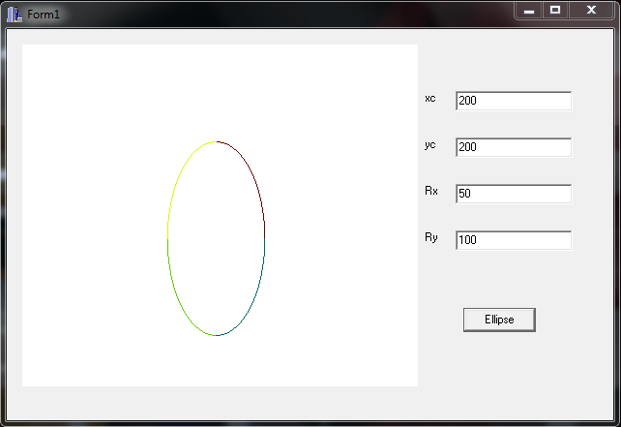

**CONCLUSION:**

Hence, an ellipse was drawn using mid-point algorithm.